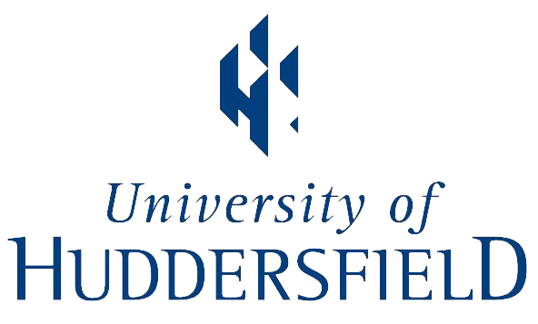

The School of Music, Humanities and Media at the University of Huddersfield invites proposals from researchers seeking to apply for a Marie Skłodowska-Curie Individual Fellowship 2019 based at the University. Fellowships are of 12-36 months duration, depending on the scheme. Deadline for submitting an Expression of Interest to the University is Monday 29th April.

Marie Skłodowska-Curie Individual Fellowships aim to enhance the creative and innovative potential of experienced researchers, wishing to diversify their individual competence through advanced training, international mobility and intersectoral mobility. Individual Fellowships provide opportunities to acquire and transfer new knowledge and to work on research and innovation in a European context or outside Europe. They develop the careers of individual researchers who show great potential and include a specific opportunity for those returning to the profession. The proposal is built around a concrete plan of training-through-research at the host organisation. In addition to research objectives, this plan comprises the researcher’s training and career needs, including training on transferable skills, planning for publications, and participation in conferences. The scheme offers a highly competitive salary, family allowance, and travel allowance, as well as research and training expenses.

The School will support up to 10 outstanding applications for Marie Skłodowska-Curie Individual Fellowships for research projects in any field within any area of the School including:

English
Creative writing
History
Drama
Journalism and Media
Linguistics,
Modern languages
Music (including popular music, performance, musicology, analysis)
Music technology

Two schemes are available under this call:

The European Fellowships - held in EU Member States or Associated Countries and open to researchers either coming to Europe from any country in the world or moving within Europe. Applicants cannot have resided or carried out the main activity (work, studies, etc.) in the host country for more than 12 months in the last 36 months before the call deadline. Fellowships last for a duration of 12-24 months. An optional secondment period of up to 3 or 6 months in another organisation in Europe is eligible where this would boost the impact of the fellowship.
A Career Restart (12-36 months) option and Reintegration to Europe (12-24 months) option is available within the European Fellowships scheme. The fellowship structure is the same, though eligibility requirements for these routes differ. Please see the below link for more information on these routes.

The Global Fellowships – composed of an outgoing phase during which the researcher first undertakes mobility to a partner organisation in a Third Country (not an EU Member State or Associated Country) for an uninterrupted period of between 12 and 24 months, followed by a mandatory 12-month return period to the single beneficiary located in a Member State or Associated Country, in this case the University of Huddersfield. Applicants must be a national or long-term resident (i.e. undertaken a period of full-time research activity in a MS/AC of at least 5 consecutive years) of a Member State or Associated Country. The applicants must not have resided or carried out the main activity (work, studies, etc.) in the Third Country where the initial outgoing phase takes place for more than 12 months in the last 36 months immediately before the call deadline. An optional secondment period of up to 3 or 6 months in another organisation in Europe is eligible where this would boost the impact of the fellowship.

For both the European and Global Fellowships the below salary and expenses details apply:
Salary €6,822.24 a month
Family Allowance (where applicable) €500 a month
Mobility Allowance €600 a month
Research, training and networking activities €800 a month

The funder’s deadline for the full application is 11 September 2019. In order to allow time for mentoring and development of full applications, expressions of interest should be sent to Professor Monty Adkins (m.adkins@hud.ac.uk) by 5pm on Monday 29th April, consisting of two PDF documents:

1) a two-page CV including education, publications, any awards, exhibitions;
2) a two-page draft statement of the research project to be undertaken and intended training/networking requirements.

A selection process internal to the School of Music, Humanities and Media will determine which proposals will go forward to a full application. A programme of mentoring and development will be offered to applicants deemed successful in this internal process.

For further information on the scheme, including eligibility, see the European Commission Research and Innovation website:
https://ec.europa.eu/info/funding-tenders/opportunities/portal/screen/opportunities/topic-details/msca-if-2019

https://ec.europa.eu/info/funding-tenders/opportunities/portal/screen/opportunities/topic-details/msca-if-2019

